**How to programme the Teensy with the code for the VSTCM PCB**

1/ Download the code from Github and unzip it.

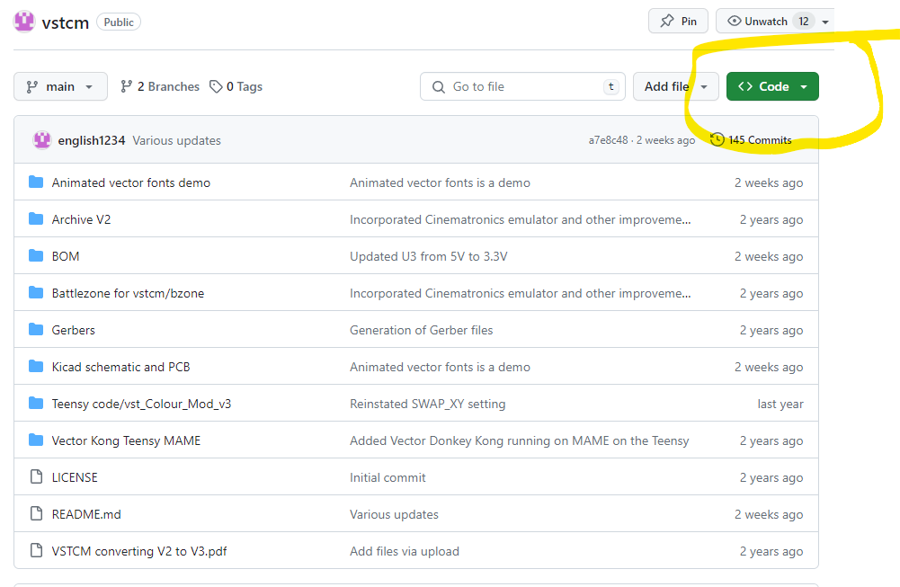

2/ Open Arduino IDE

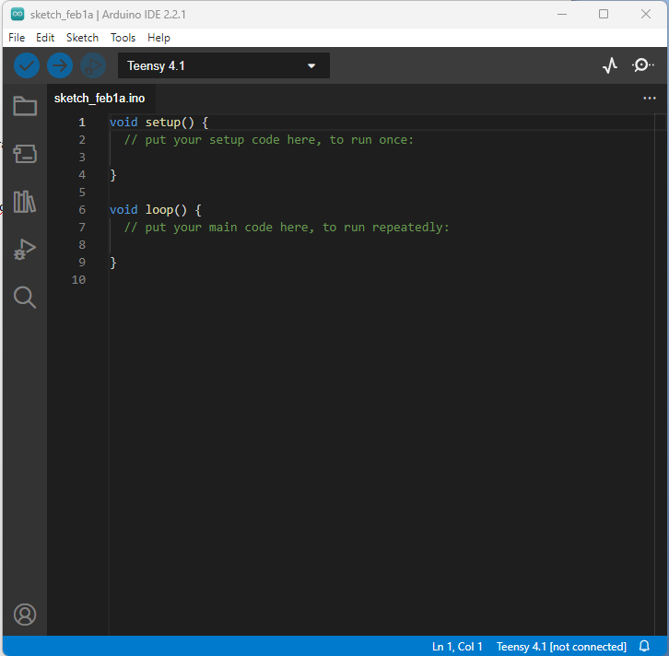

Open vst_Colour_Mod_v3 .ino (File->Open…) in the Teensy code directory of the unzipped directory.

Make sure the Teensy 4.1 board is selected, and set the code to “Fastest” and 816Mhz.

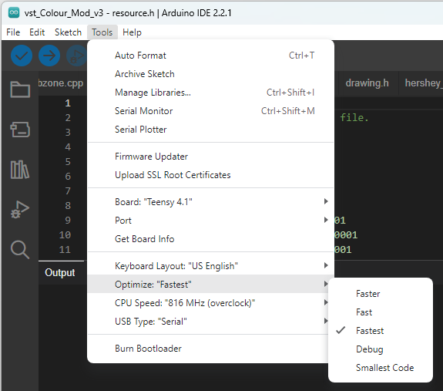

Connect the Teensy with a USB cable to the PC. Press the blue circle with a tick (check) to compile the sketch.

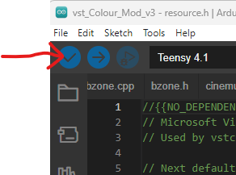

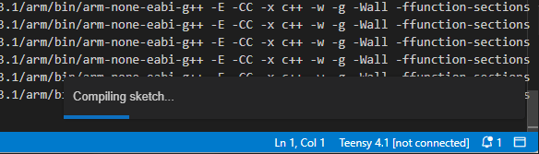

If the sketch compiles correctly (there might be missing libraries to sort out), the following screen should appear (it may be an icon on the task bar)

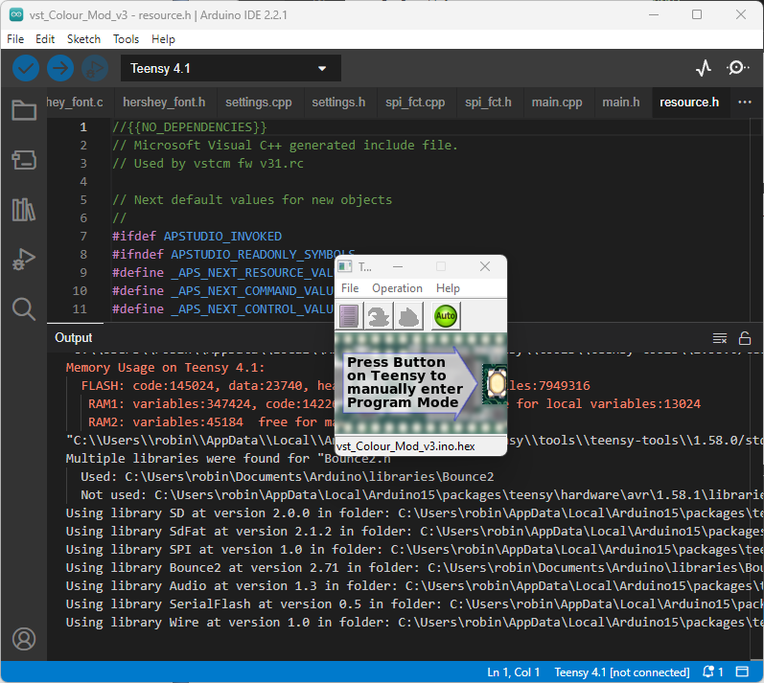

Press the white button on the Teensy to upload the code. It is now programmed and can be disconnected and is ready for use.

Once the VSTCM is powered up and connected to a vector monitor or oscilloscope, the menu screen should display.